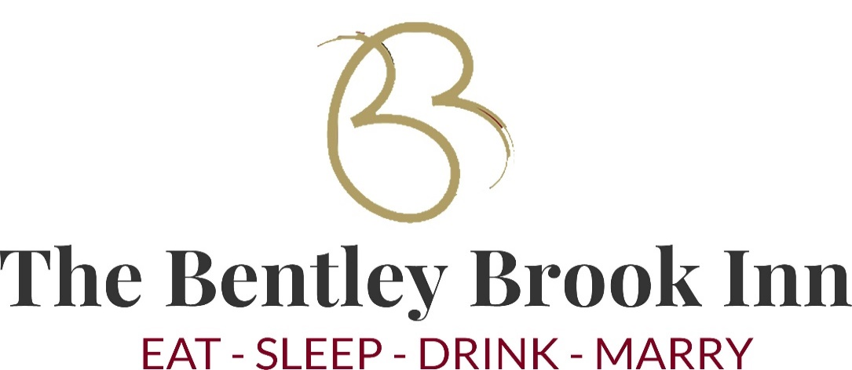
Available Monday – Friday 7.30am – 9.30am Saturday & Sunday 8am – 10am

Glass of Fruit Juice £1.50 Packet of Cereals £1.95 Fresh Fruit £2.25
Warm croissant x 2 served with butter and preserves £4.00 White or brown toast x 2 served with butter and preserves £3.00
Bacon or Sausage Cob served on white or brown sliced bread, toast or white cob £4.00. Add egg or mushroom for £0.50

Full English Breakfast with bacon, sausage, egg, mushroom, baked beans & hash brown, includes tea / coffee and toast £15.00 (incl fruit juice)
Vegetarian Breakfast with vegan sausage, egg, mushroom, baked beans, hash brown & fried bread, includes tea / coffee and toast £14.00 (incl fruit juice)
Vegan Breakfast with vegan sausage, mushroom, hash brown and beans, includes tea / coffee and toast (vegan butter available) £14.00
Derbyshire Oatcake served with bacon & cheese or bacon & scrambled egg or sausage & cheese or scrambled egg & black pudding £13.00
Eggs on Toast, poached, boiled, scrambled or fried served on white or brown toast £5.00
Baked Beans on Toast, served on white or brown toast £4.00

A Pot of Tea £2.50 Speciality Teas available £2.50
Filter Coffee / Americano £2.50 Latte £2.95 Cappuccino £2.95
Moccachino £2.95 Latte Macchiato £2.95
Hot Chocolate £2.95

